

Project Closure Report

March 26

COMPANY NAME: Safari Pvt. Ltd.
Authored by: Nirav Parekh



Acknowledgement
The successful completion of this project stands as a testament to the collaborative efforts, professional commitment, and strategic guidance provided by all stakeholders involved.

We would like to express our sincere appreciation to the Client for their trust, vision, and continuous support throughout the project lifecycle. Their proactive decision-making and valuable inputs were instrumental in achieving the project objectives.
We extend our gratitude to all Consultants, Contractors, and Vendors for their dedicated efforts, technical expertise, and adherence to quality and safety standards, which ensured timely and efficient execution.

As the Project Management Consultant (PMC), we are proud to have contributed to the planning, monitoring, and successful delivery of this project. We acknowledge the coordinated teamwork and effective communication that enabled the project to be completed in alignment with defined scope, cost, time, and quality benchmarks.
This project reflects a collective achievement, and we thank all contributors for their commitment to excellence.

Project Brief
The Safari Industrial Plant Project is a large-scale industrial development located in the industrial corridor of Sanand, Ahmedabad, Gujarat. The project is being developed to establish a state-of-the-art manufacturing facility with integrated utilities, warehousing, and administrative infrastructure.
The plant is designed to support heavy industrial operations, including production, assembly, storage, and dispatch functions. The development focuses on operational efficiency, safety compliance, and future scalability, aligning with modern industrial standards.
The project is being developed by Safari Industries (India) Ltd., aiming to expand its manufacturing capabilities and strengthen its supply chain network across domestic and international markets.
The facility includes production blocks, warehouse zones, utility buildings, internal roads, drainage systems, and administrative offices, making it a fully integrated industrial ecosystem.
Sr. No. | Particular | Details
1 | Project Name | Safari Industrial Plant Project
2 | Project Location | GIDC Industrial Estate, Sanand Phase II, Ahmedabad, Gujarat – 382170
3 | Project Objective | To develop a modern industrial manufacturing facility with integrated infrastructure
4 | Project Type | Industrial (Manufacturing Plant + Warehouse)
5 | Client / Developer | Safari Industries (India) Ltd.
6 | Project Management Consultant (PMC) | Sharnam PMC PVT. LTD
7 | Architectural Consultant | INI Design Studio
8 | Structural Consultant | JW Consultants LLP
9 | MEP Consultant | Sterling & Wilson Engineering
10 | Total Project Cost | INR 120 Crores (Approx.)
15 | Main Contractor (Civil & PEB) | L&T Construction

Below image gives illustrate the site location which is located at Ahmedabad.
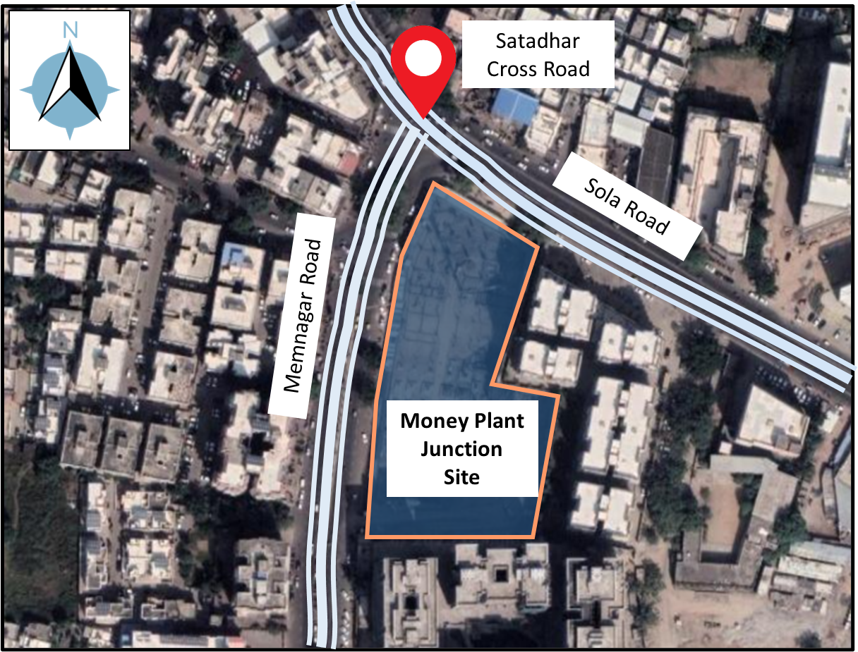

Project Performance Analysis
This section briefly indicates the project insights in terms of project timeline, cost performance, quality performance, and safety performance.

Schedule Performance:
- Planned Project Duration: 18 Months (Jan 2023 – Jun 2024)
- Actual Project Duration: 20 Months (Jan 2023 – Aug 2024)
- Overall Delay: 2 Months (~11% delay)

Milestone Achievement Analysis:
Milestone | Planned | Actual | Status
Site Mobilization | Jan 2023 | Jan 2023 | Achieved
Excavation Completion | Mar 2023 | Apr 2023 | Delayed
Foundation Completion | Jun 2023 | Jul 2023 | Delayed
PEB Erection | Dec 2023 | Jan 2024 | Delayed
Finishing & MEP | May 2024 | Jul 2024 | Delayed
Project Completion | Jun 2024 | Aug 2024 | Delayed

Delays & Causes
- Delay in statutory approvals (initial phase)
- Unseasonal heavy rainfall impacting excavation
- Delay in PEB material procurement
- Minor design revisions during execution

Recovery Measures
- Fast-tracking of PEB erection activities
- Deployment of additional manpower and shifts
- Parallel execution of MEP and finishing works
- Weekly PMC-driven review meetings

The below MSP file is the final submitted baseline file of the project.

Cost Performance:
The project recorded a total cost overrun of INR 8 Crores, leading to a Cost Performance Index (CPI) of 0.93. The final estimated cost at completion (EAC) stands at INR 128 Crores, reflecting a 6.7% increase over the original budget. The cost deviation was mainly driven by material price escalation and scope enhancements. Attached Excel file reflect the final project cost performance.

Budget vs Actual Cost:
- Approved Budget: INR 120 Crores
- Actual Cost at Completion: INR 128 Crores
- Cost Overrun: 6.7%

Cost Variations:
- Increase in steel prices (8–10%)
- Additional cost due to design changes
- Acceleration costs for delay recovery

Change Orders Impact:
- Total Change Orders: 12 Nos.
- Value Impact: INR 8 Crores
- Major changes:
  - Additional utility block expansion
  - Upgraded industrial flooring specifications

Quality Performance:
The overall quality performance of the project remained strong, with a Quality Compliance Index of approximately 98%. The project maintained a low NCR generation rate, with 96% of NCRs successfully closed, and minimal rework observed (less than 2%), indicating effective quality control and adherence to specifications.

The below attached file is project quality master file at the end of project.

QA/QC Procedures
- Implementation of ITP (Inspection & Test Plans)
- Regular material testing (cube test, steel test)
- Third-party inspections for critical works
Inspection & Testing Summary
- Concrete Cube Tests: 100% compliance
- PEB Alignment Checks: Within tolerance limits
- Flooring Flatness (FF/FL): Achieved as per standards
NCRs & Closure Status
- Total NCRs Raised: 28
- Closed: 27
- Open: 1 (minor – under observation)

Safety Performance:
The project demonstrated excellent safety performance, achieving zero Lost Time Injuries (LTI) and maintaining a Total Recordable Incident Rate (TRIR) of 0.8. Safety compliance consistently exceeded 95%, supported by regular audits and strict enforcement of HSE protocols.
The below attached file is project safety master file at the end of project.

Safety Plan Implementation
- Approved HSE Plan implemented
- Daily toolbox talks
- Mandatory PPE compliance

Incident/Accident Records
- Total Incidents: 5 minor
- Major Accidents: 0
- Lost Time Injury (LTI): Nil

Safety Audits & Compliance
- Monthly safety audits conducted
- Compliance Level: >95%
- Safety awards issued for best-performing teams

Risk Management
The project faced moderate risks primarily related to material price fluctuations, supply chain disruptions, and weather conditions. These risks were effectively mitigated through proactive planning, alternate vendor strategies, and buffer provisions. Residual risks remained minimal and did not significantly impact project delivery.

The project was exposed to several execution-stage risks, primarily including material price escalation, which impacted cost planning, and supply chain delays, especially for critical items like PEB components. Additionally, unfavorable weather conditions during early stages and intermittent labor availability issues posed challenges to maintaining the planned schedule.

To mitigate these risks, proactive strategies were implemented, including rate contracts for key materials such as steel to control price fluctuations and maintaining buffer stock for critical items to avoid work stoppages. Furthermore, alternate vendor sourcing and parallel procurement planning were adopted to reduce dependency on single suppliers and ensure continuity of work.

Despite mitigation efforts, minor residual risks remained, particularly in the form of slight delays during finishing activities and continued dependency on specialized vendors for certain works. However, these risks were closely monitored and did not significantly impact the overall project delivery.

The below attached file is project Risk master file at the end of project.

Regulatory Compliance
The project obtained all necessary statutory approvals, including Building Plan Approval from the local authority, Fire NOC from the fire department, Environmental Clearance from the concerned regulatory body, and Factory License for industrial operations. These approvals were secured in a phased manner prior to and during execution to ensure uninterrupted project progress.
The project maintained full compliance with all applicable statutory and regulatory requirements throughout its lifecycle. Regular inspections and documentation reviews ensured adherence, and all mandatory approvals were successfully obtained prior to project completion without any major non-compliances.
The project has received key completion certifications, including the Building Completion Certificate from the local authority and final Fire Clearance approval, confirming that the facility meets all safety and regulatory standards. These certifications enabled formal handover and operational readiness of the plant.

The below attached file is project Legal Compliance master file at the end of project.

Handover & Commissioning
All major systems including electrical systems, fire fighting systems, HVAC systems, and DG backup systems were thoroughly tested and commissioned in accordance with approved specifications and relevant standards. Testing was carried out in coordination with contractors, consultants, and client representatives to ensure system readiness and operational reliability.
The testing and commissioning results confirmed that all installed systems are functioning within acceptable operational parameters and meeting the required performance criteria. Minor observations identified during testing were rectified prior to final handover, ensuring seamless operational readiness.
All essential handover documents, including as-built drawings, Operation & Maintenance (O&M) manuals, and warranty certificates, have been compiled and submitted to the client. These documents provide a comprehensive record of executed works and facilitate smooth operation and maintenance of the facility post-handover.
The project was formally handed over to the client on 15th August 2026, following successful completion of all works and documentation. The client has reviewed and accepted the project deliverables, confirming satisfactory completion in line with contractual and technical requirements.

Financial Closure
The contractor’s final bill has been duly verified, reviewed, and certified by the PMC in accordance with contract conditions. All quantities and claims were validated to ensure accuracy and compliance with the approved scope.
Approximately 95% of the total project payments have been released to the contractor based on certified bills. The remaining amount is being withheld as retention, in line with contractual provisions.
The retention amount is scheduled to be released upon successful completion of the Defect Liability Period (DLP), subject to satisfactory performance and closure of any outstanding defects.
The total project cost at completion stands at INR 128 Crores, reflecting a controlled cost overrun within acceptable limits considering scope changes and market variations.

Lesson Learned
What Went Well:
The project benefited from a strong PMC monitoring and control system, ensuring consistent tracking of progress, cost, and quality. Effective coordination among stakeholders and a proactive safety culture contributed significantly to successful project delivery.

Areas of Improvement:
Improvement opportunities were identified in early-stage procurement planning and ensuring a more robust design freeze prior to execution. Addressing these aspects could further minimize delays and rework in future projects.

Recommendations:
It is recommended to adopt digital project management tools for real-time monitoring and strengthen vendor prequalification processes to ensure timely delivery and quality assurance in future projects.

PMC Performance Review
KPI Achievement:
The PMC achieved strong performance across key metrics, with quality (98%) and safety rated as excellent, while maintaining reasonable control over schedule (89%) and cost (93%). Overall performance reflects effective project management practices.

Client Feedback:
The client provided an overall rating of “Very Good”, appreciating the PMC’s structured reporting, proactive coordination, and timely decision-making support throughout the project lifecycle.

Internal Evaluation:
Internal assessment indicates strong control over quality and safety management systems, while highlighting the need for improvement in procurement tracking and early risk anticipation for enhanced performance.

Document List
All relevant project documents, including approved drawings, contracts and agreements, inspection reports, test certificates, safety records, and progress photographs, have been systematically compiled and submitted as part of the project closure documentation for record and future reference.

Project Closure Certificate
This is to certify that the Safari Industrial Plant Project has been completed in accordance with the approved scope, technical specifications, and contractual requirements. The project has been executed to the satisfaction of all stakeholders and is recommended for formal closure.

